Round 2 Testing 13.0-03

~~Delete of file from submission does not delete file record from CIF_CHECK_STATUS. Still shows up in checkCIF results~~

~~Do custom instruction show up?~~

~~Remove more/less for custom instructions if less than 170 characters.~~

~~Select column should not show if user cannot send files for check or if no files available to be resent for check.~~

~~Should be showing subnumber in cif results page title, not pubdnumber.~~

~~Grids in results should be odd/even colored…~~

~~Grid showing all cif files for both submission files and companion files.~~

Results grid not showing:

~~File name~~

~~Size correctly~~

~~2.3.1 # 5 – unchecking Enable checkCIF checkbox should gray out View Default Instructions box and Revert to Default Instructions box.~~

~~Editor – New Editor Assignments – Details – not showing cifResults link.~~

Uncheck cifEnabled and nothing cif should show up.

~~2.4.2 – Editor/Publisher role definition, cif role items should show up after ‘View Duplicate Submission Check Results’, not before. Initiate should be first and then view.~~

~~2.6 #5 – checkCIF results link should be under Technical Check History.~~

~~2.6 #4 – checkCIF results link needs to be added to the bottom of the page links.~~

~~Details Action Link (EMDetails.aspx)~~

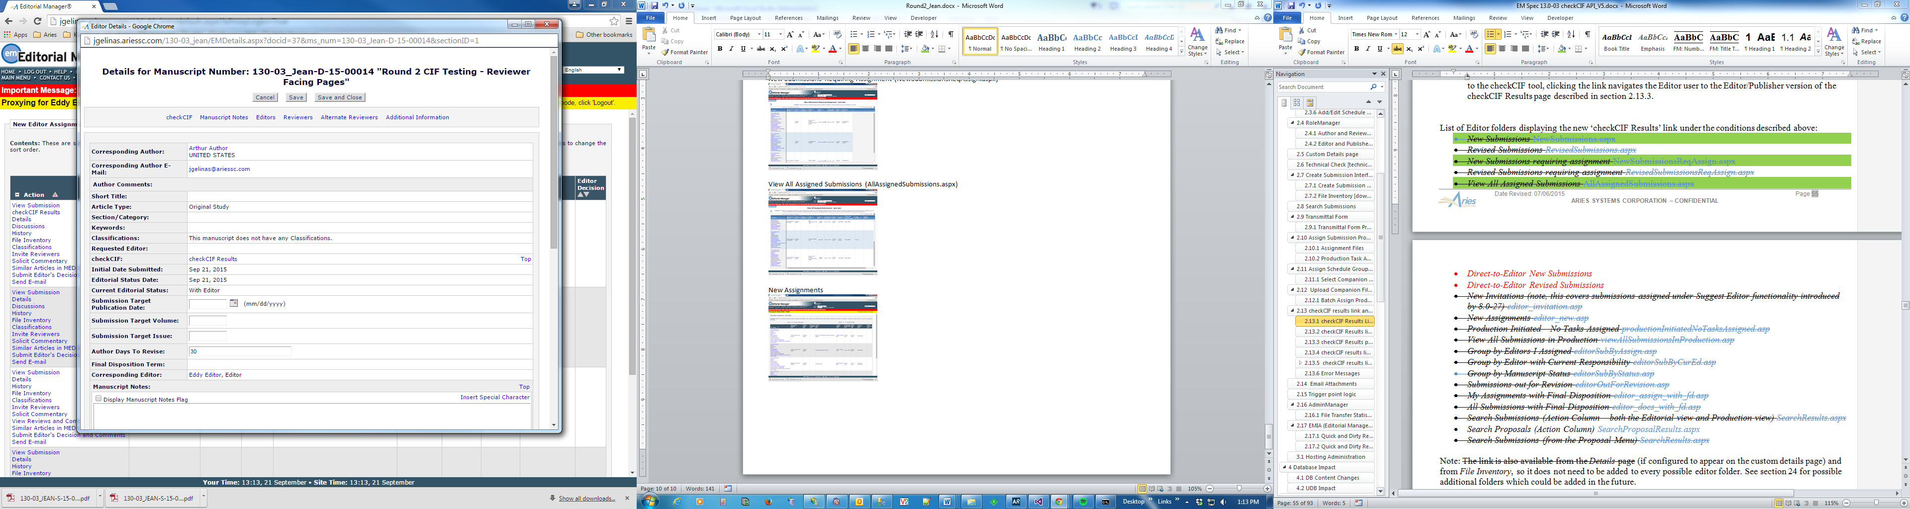

~~File Inventory (downloadSubFilesList.asp)~~

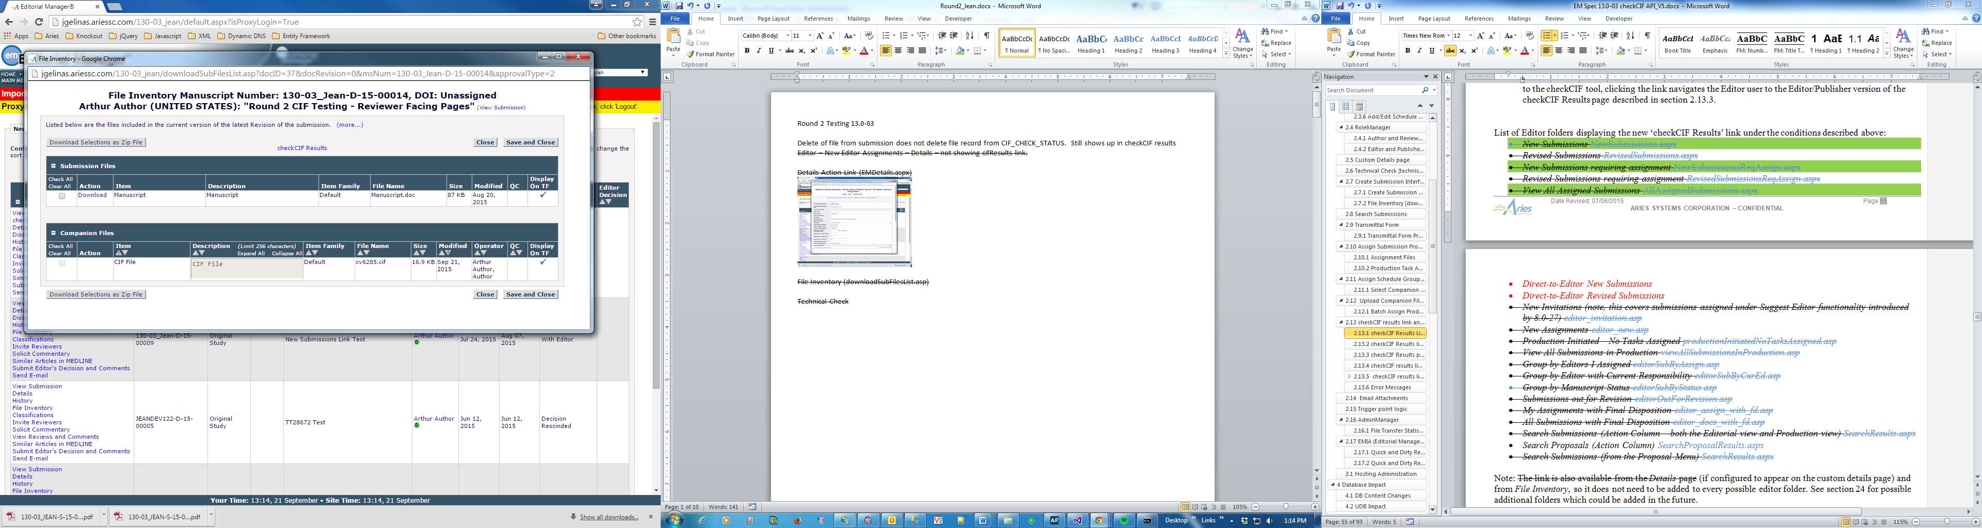

~~Technical Check~~

# AUTHOR FACING PAGES

## Authors Decision Page (process_submission_decision.asp)

*Author’s Decision page [process_submission_decision.asp] (displayed after the Author approves the PDF from the Submissions Waiting for Author’s Approval or Revisions Waiting for Author’s Approval page) –* not showing.

## ~~Author - Submissions Sent Back To Author (authorSubmissionsSentBack.asp)~~

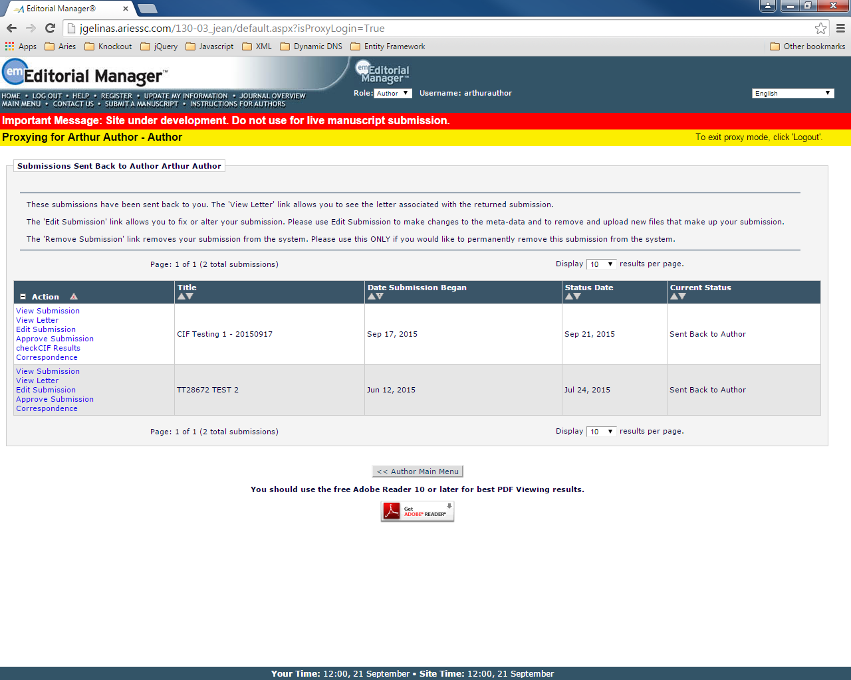

## ~~Author - Submissions Waiting for Author’s Approval (auth_ndauthApprove.asp)~~

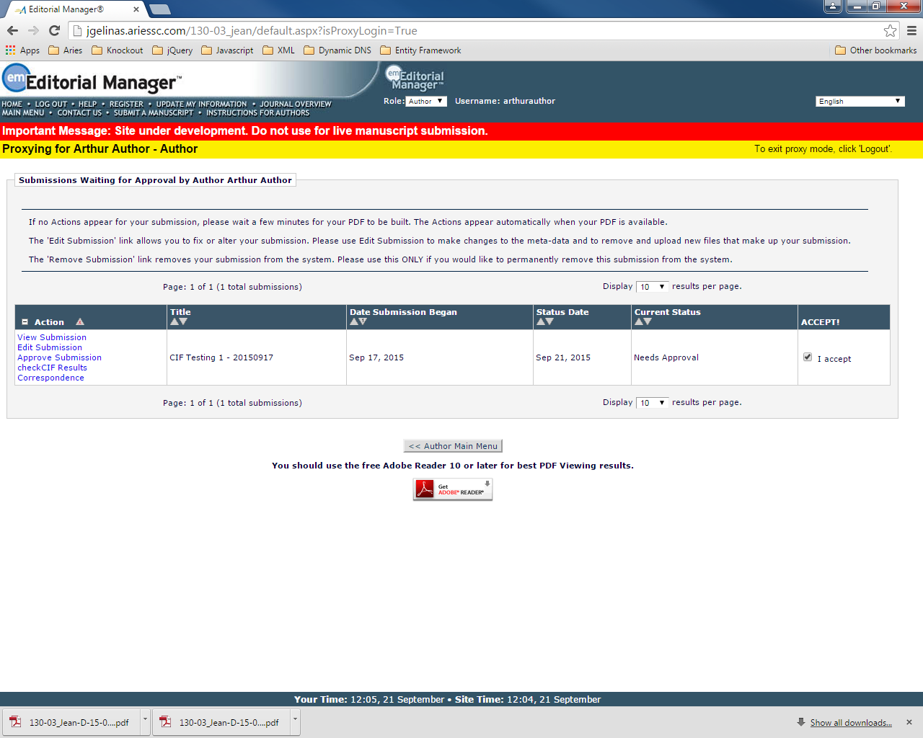

## ~~Author – Submissions Being Processed (auth_pendSubmissions.asp)~~

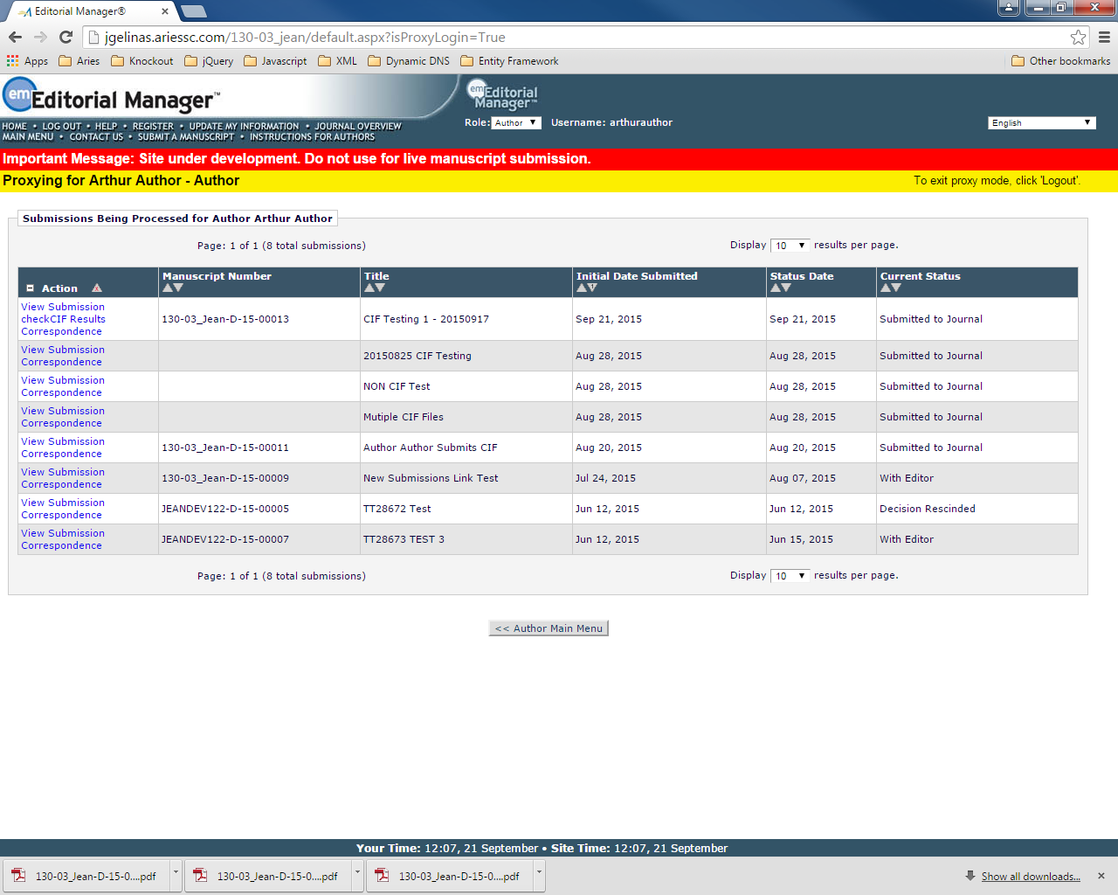

## ~~Author – Submissions Needing Revision (auth_revSubmissions.asp)~~

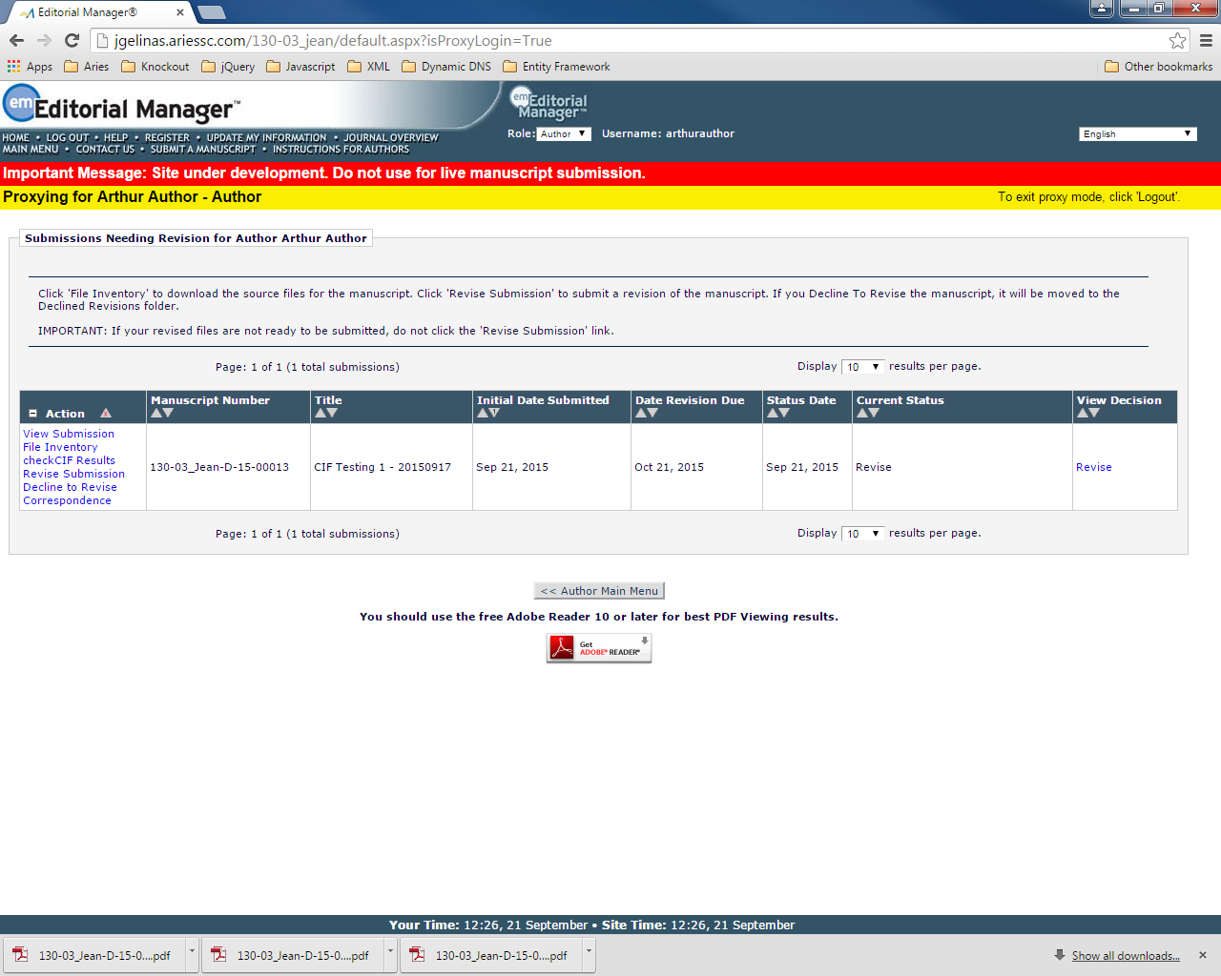

## ~~Author - Revisions Waiting for Author’s Approval (auth_RevisionsNeedingApproval.asp)~~

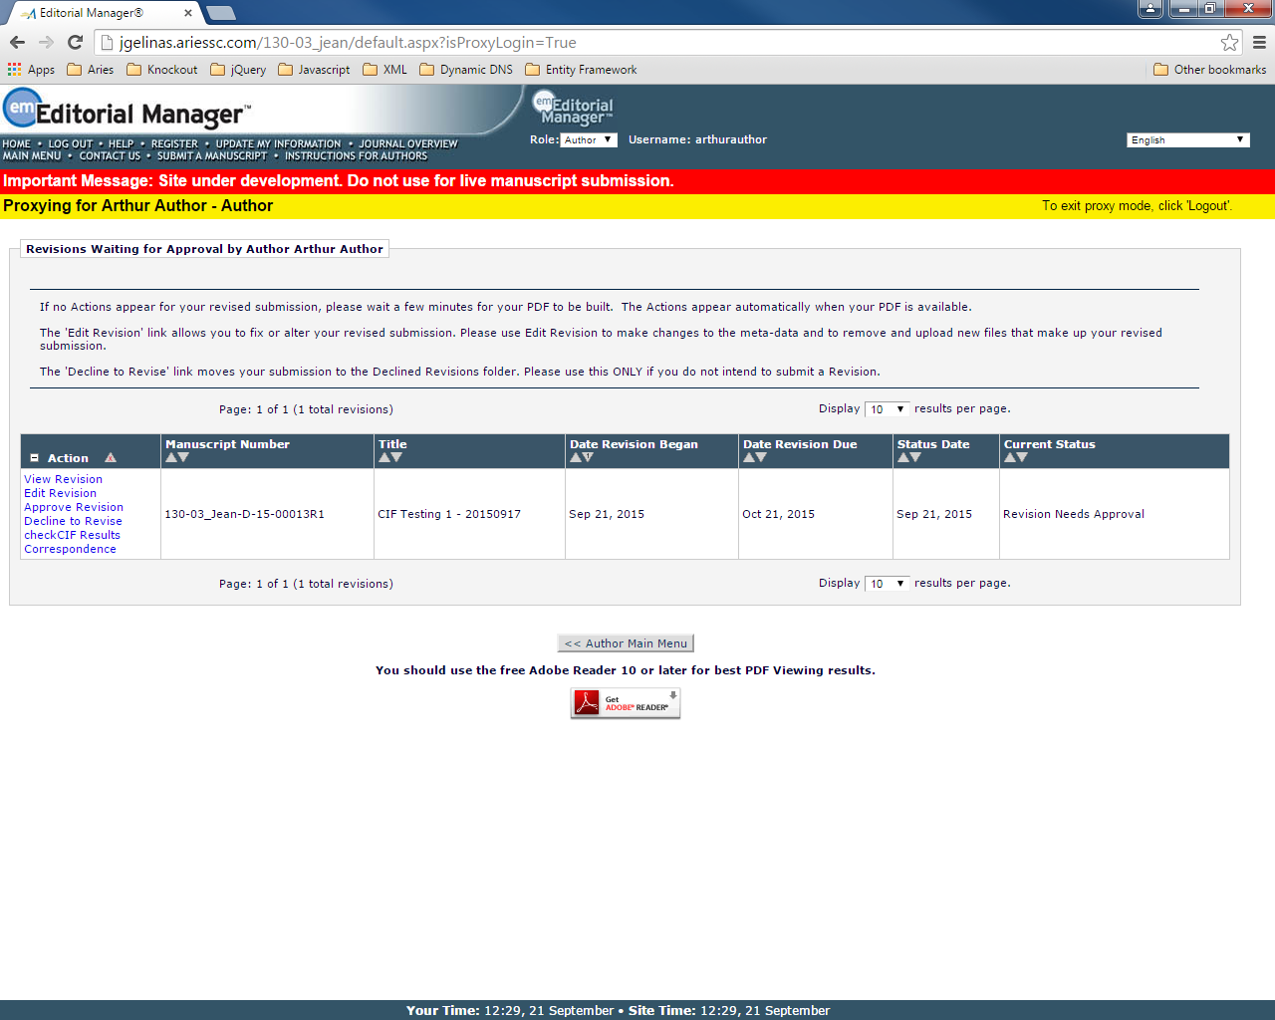

## ~~Author - Revisions Being Processed (auth_RevisionsBeingProcessed.asp)~~

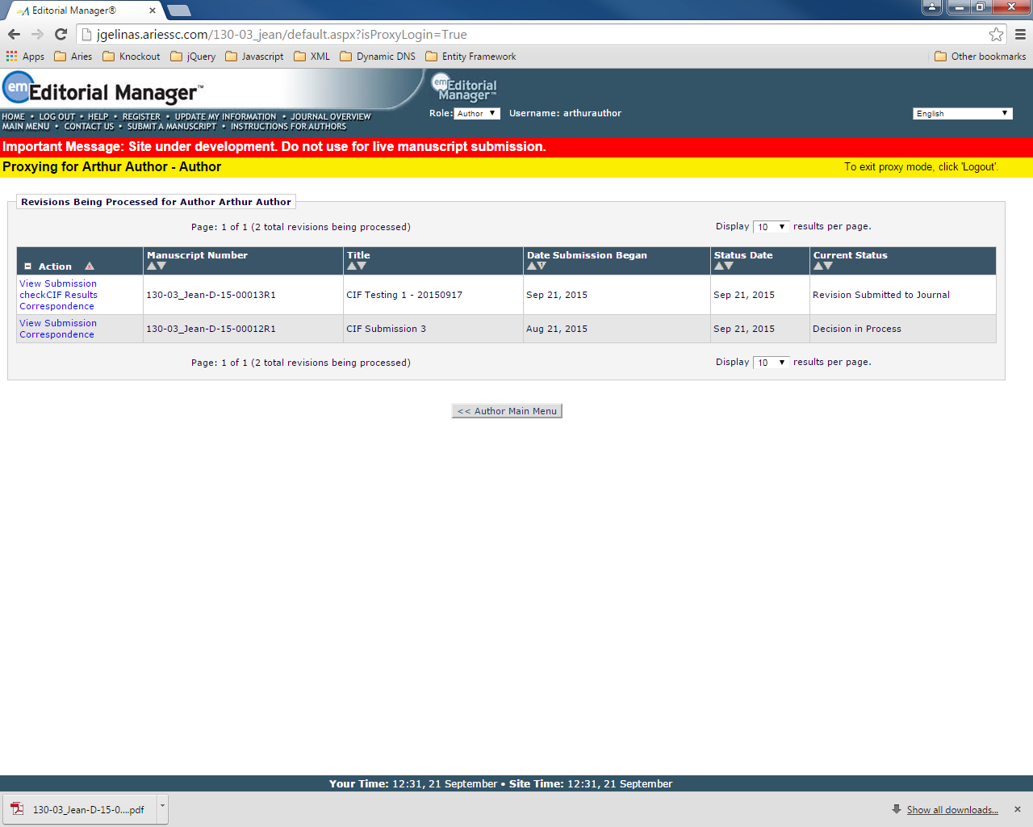

## ~~Revisions Sent Back To Author (authorRevisionsSentBack.asp)~~

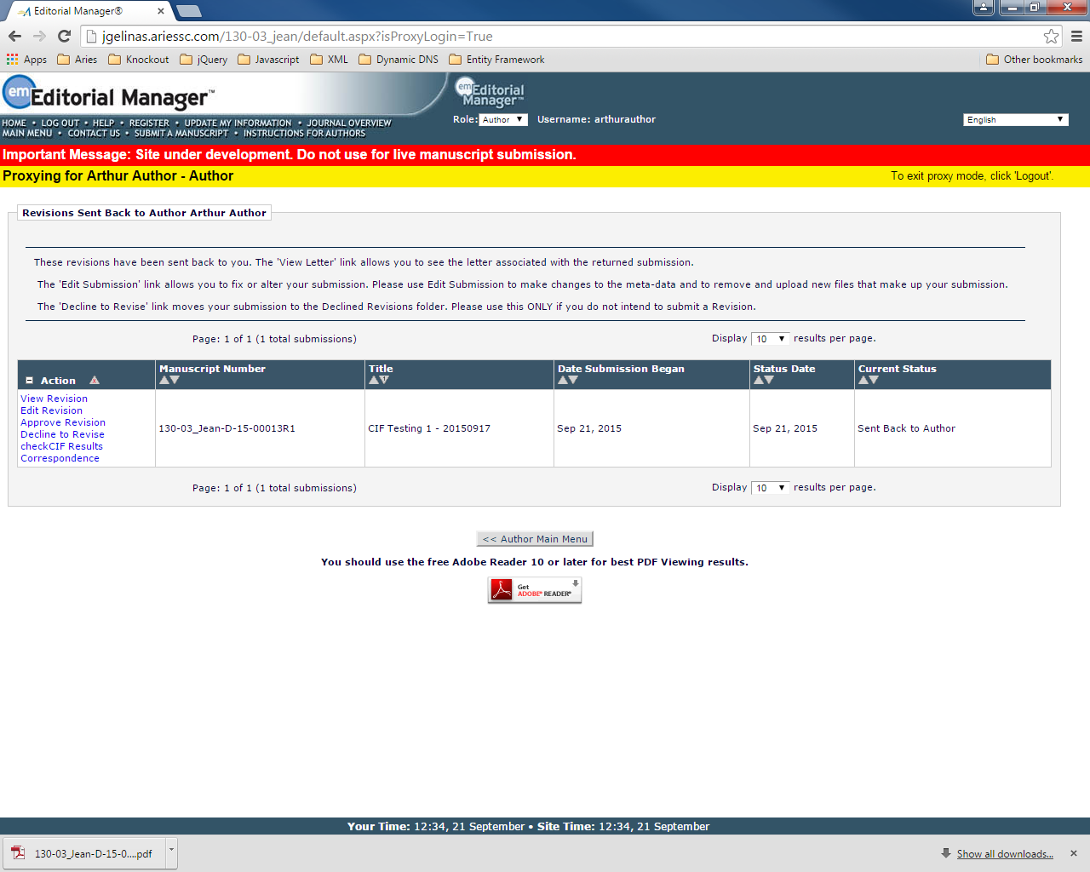

# REVIEWER FACING PAGES

## ~~Pending Assignments (reviewer_current.asp)~~

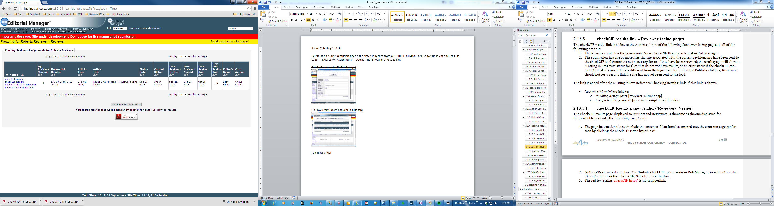

## ~~Completed Assignments (reviewer_complete.asp)~~

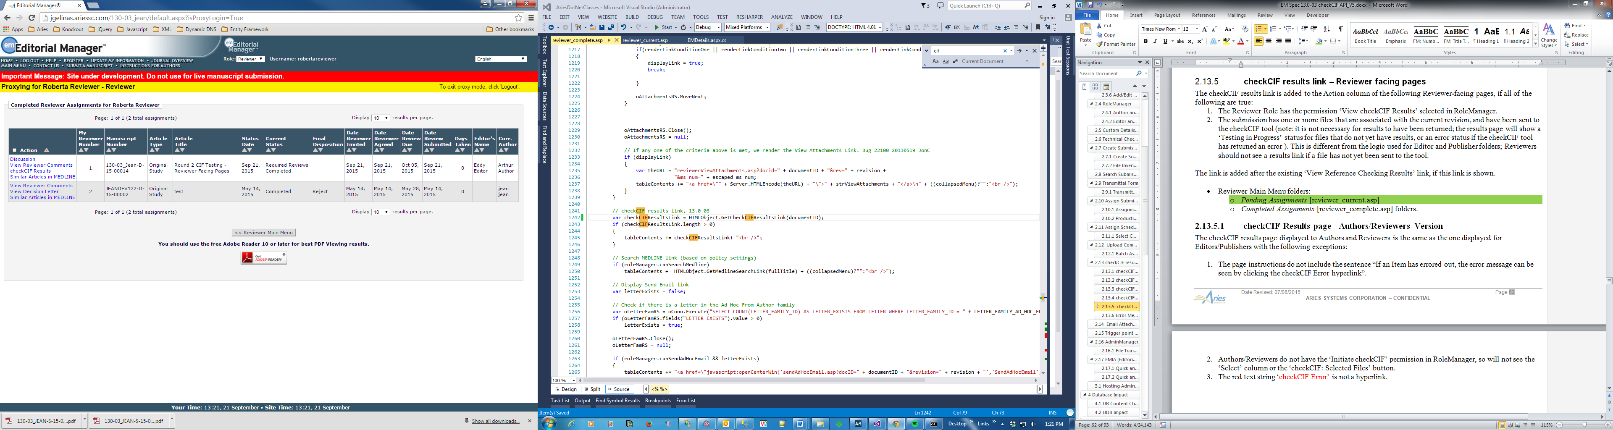

# EDITOR FACING PAGES

## ~~New Submissions (NewSubmissions.aspx)~~

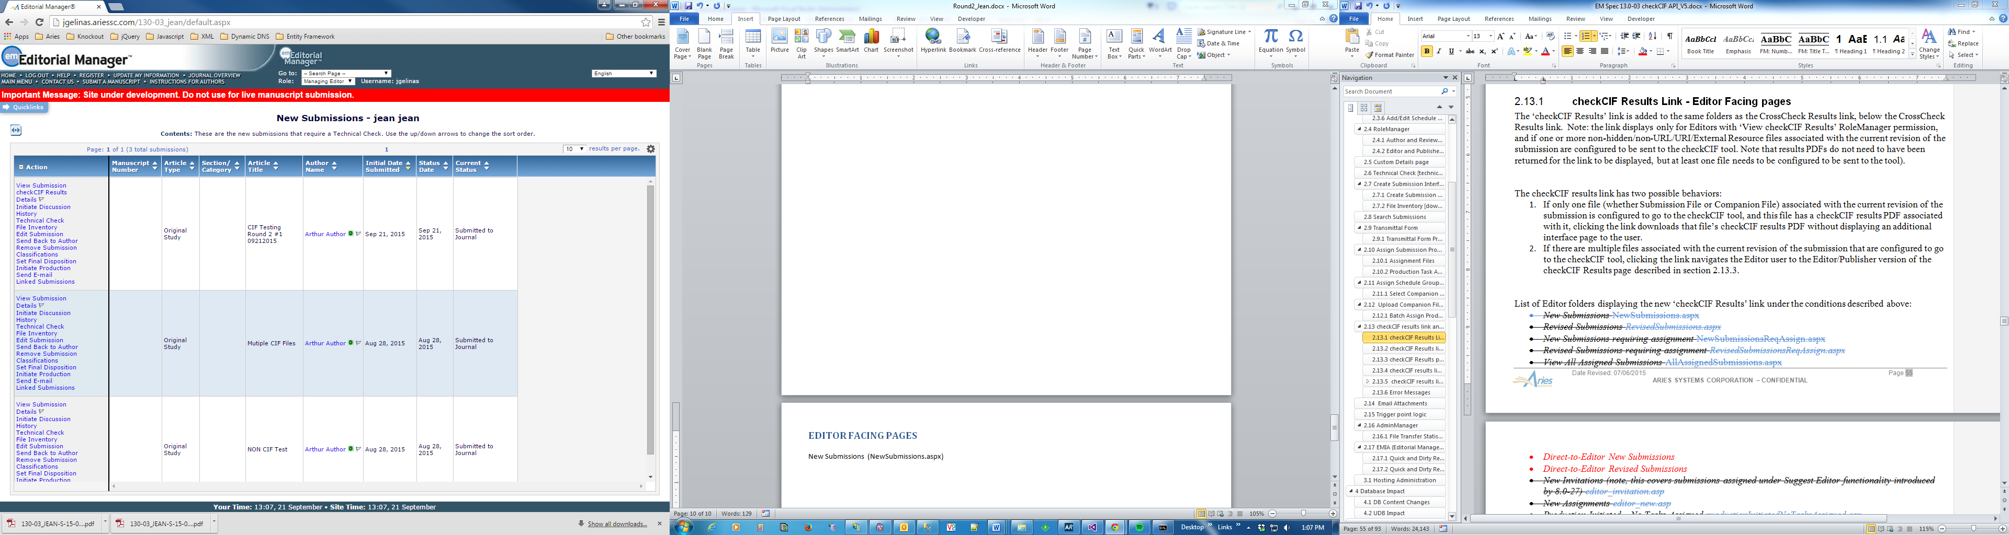

## ~~New Submissions Requiring Assignment (NewSubmissionsReqAssign.aspx)~~

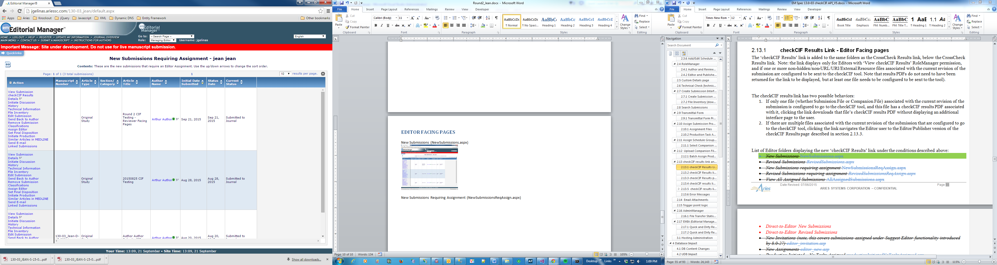

## ~~View All Assigned Submissions (AllAssignedSubmissions.aspx)~~

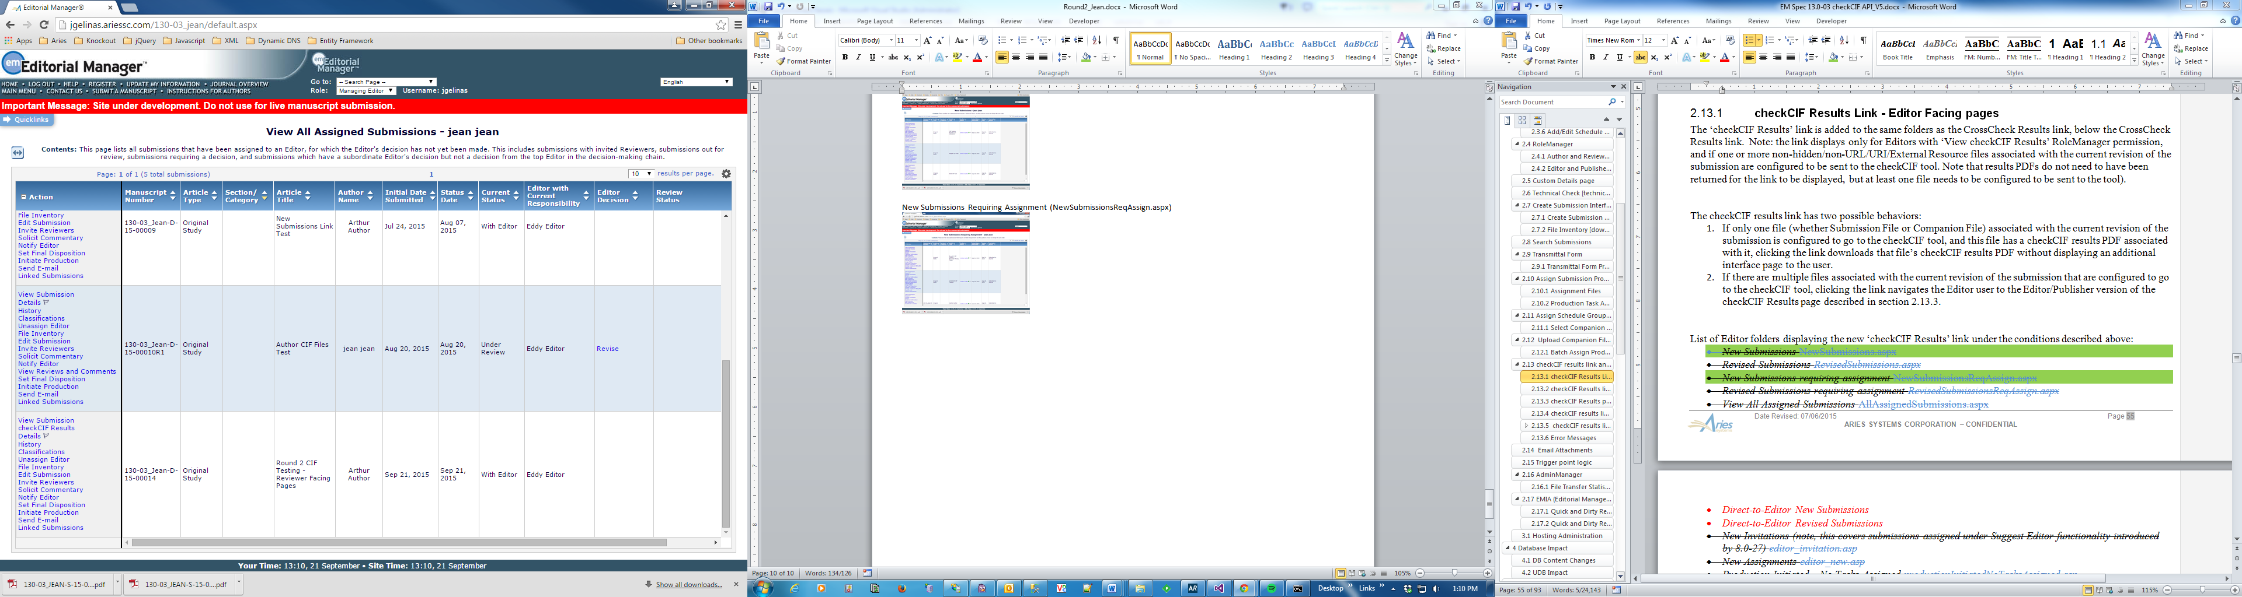

## ~~New Assignments~~

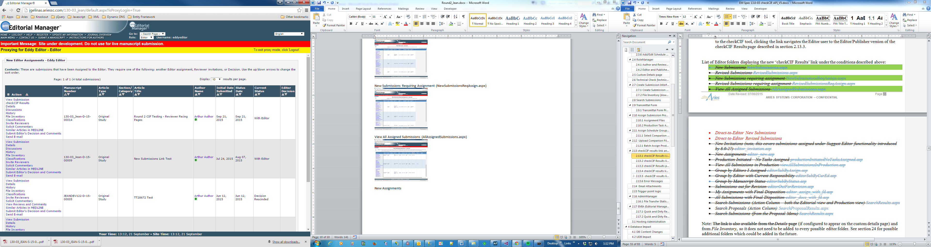

## ~~Group by Editors I Assigned (editorSubByAssign.asp)~~

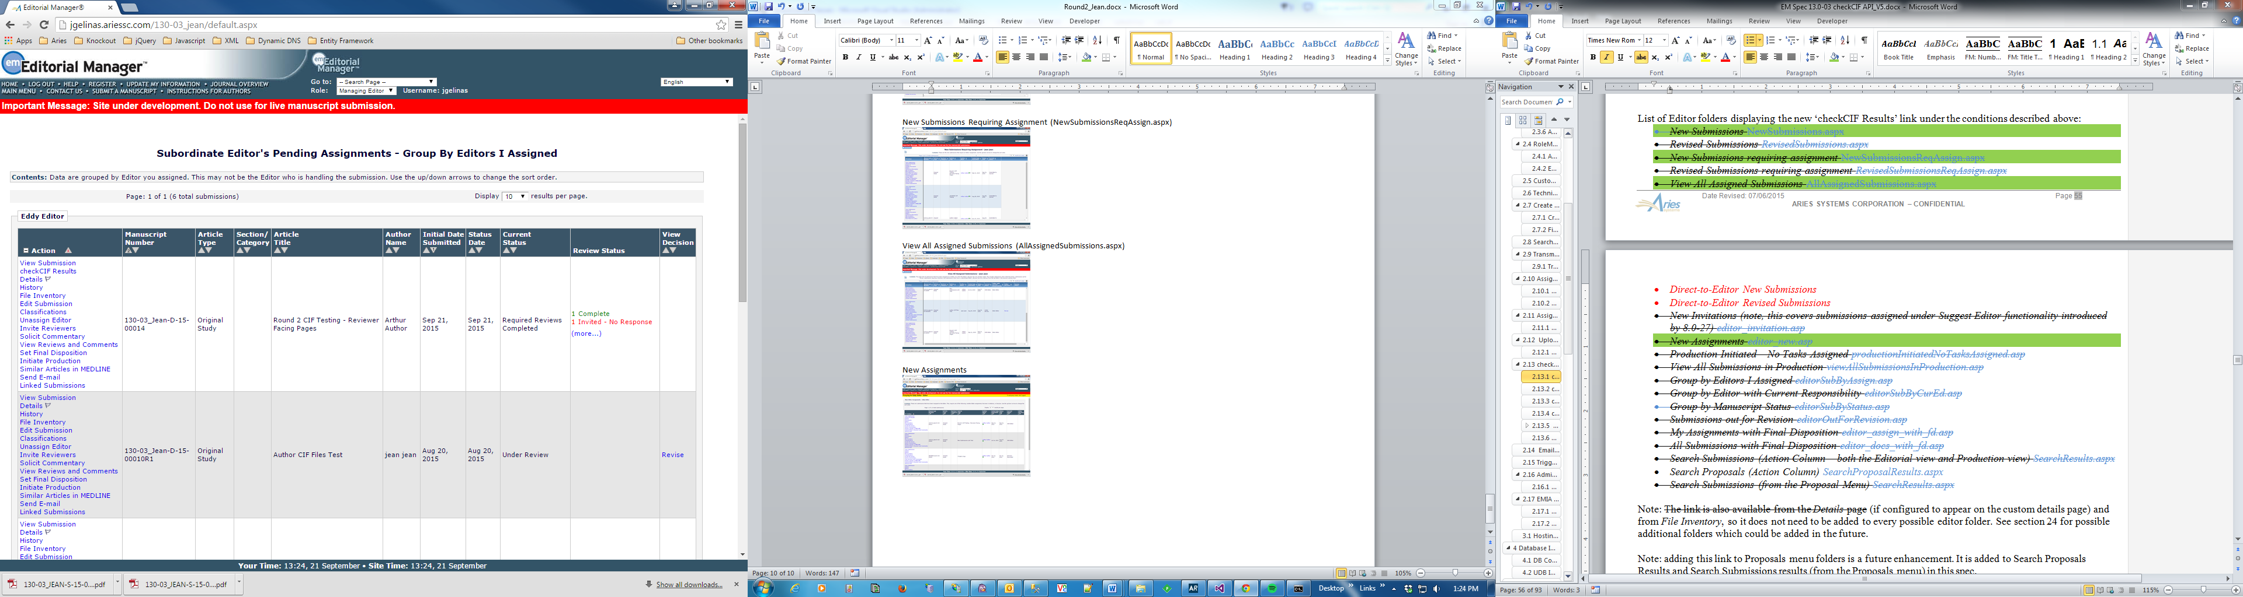

## ~~Group by Editor with Current Responsibility (editorSubByCurEd.asp)~~

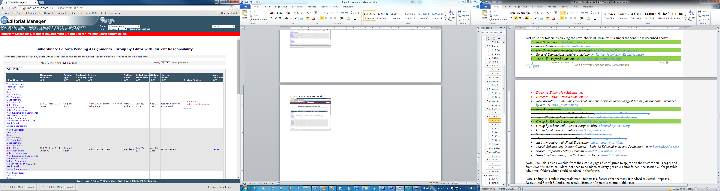

## ~~Group By Manuscript Status (editorSubByStatus.asp)~~

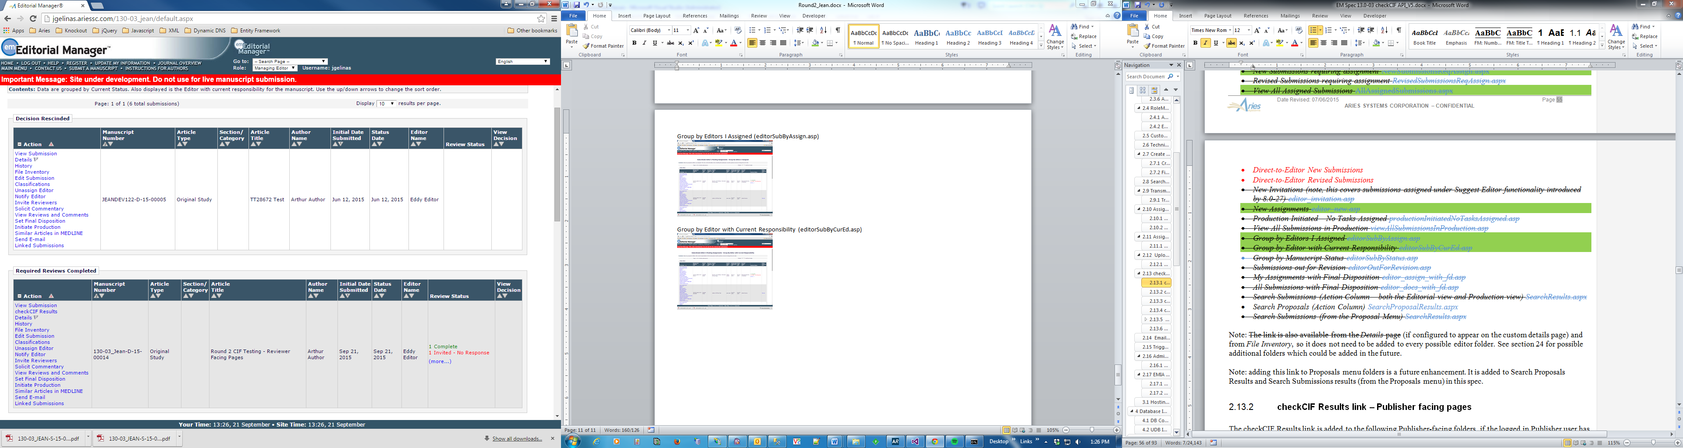

## ~~Search Submissions (SearchResults.aspx)~~

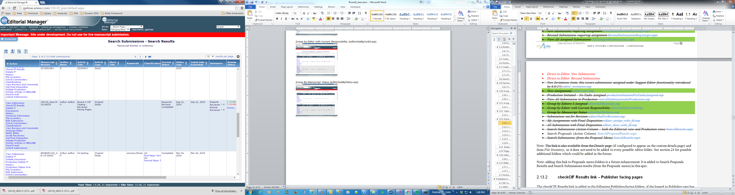

## ~~Submissions out for Revision (editorOutForRevision.asp)~~

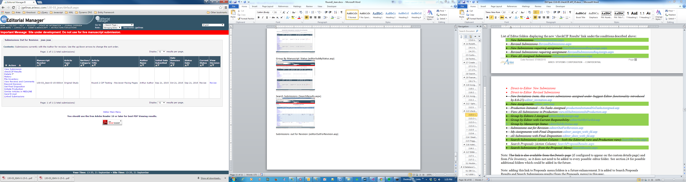

## ~~Revised Submissions (RevisedSubmissions.aspx)~~

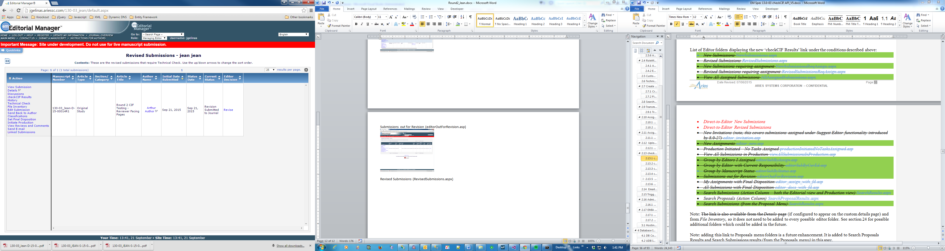

## ~~Revised Submissions Requiring Assignment (RevisedSubmissionsReqAssign.aspx)~~

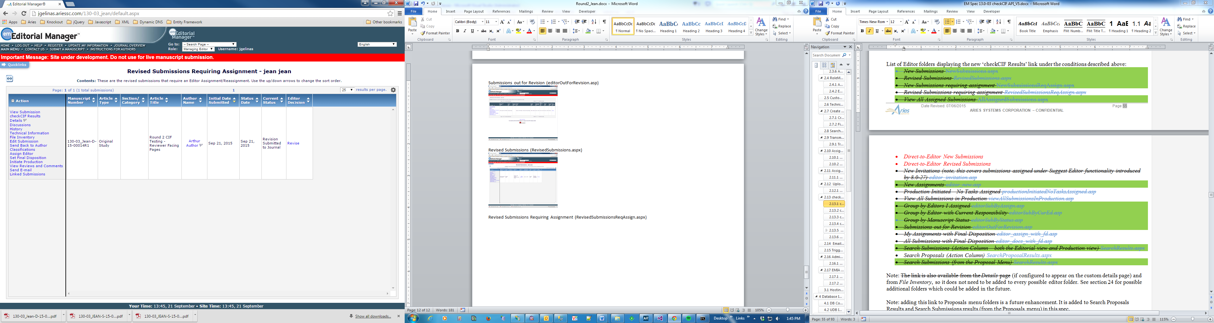

## ~~New Invitations (editor_invitation.asp)~~

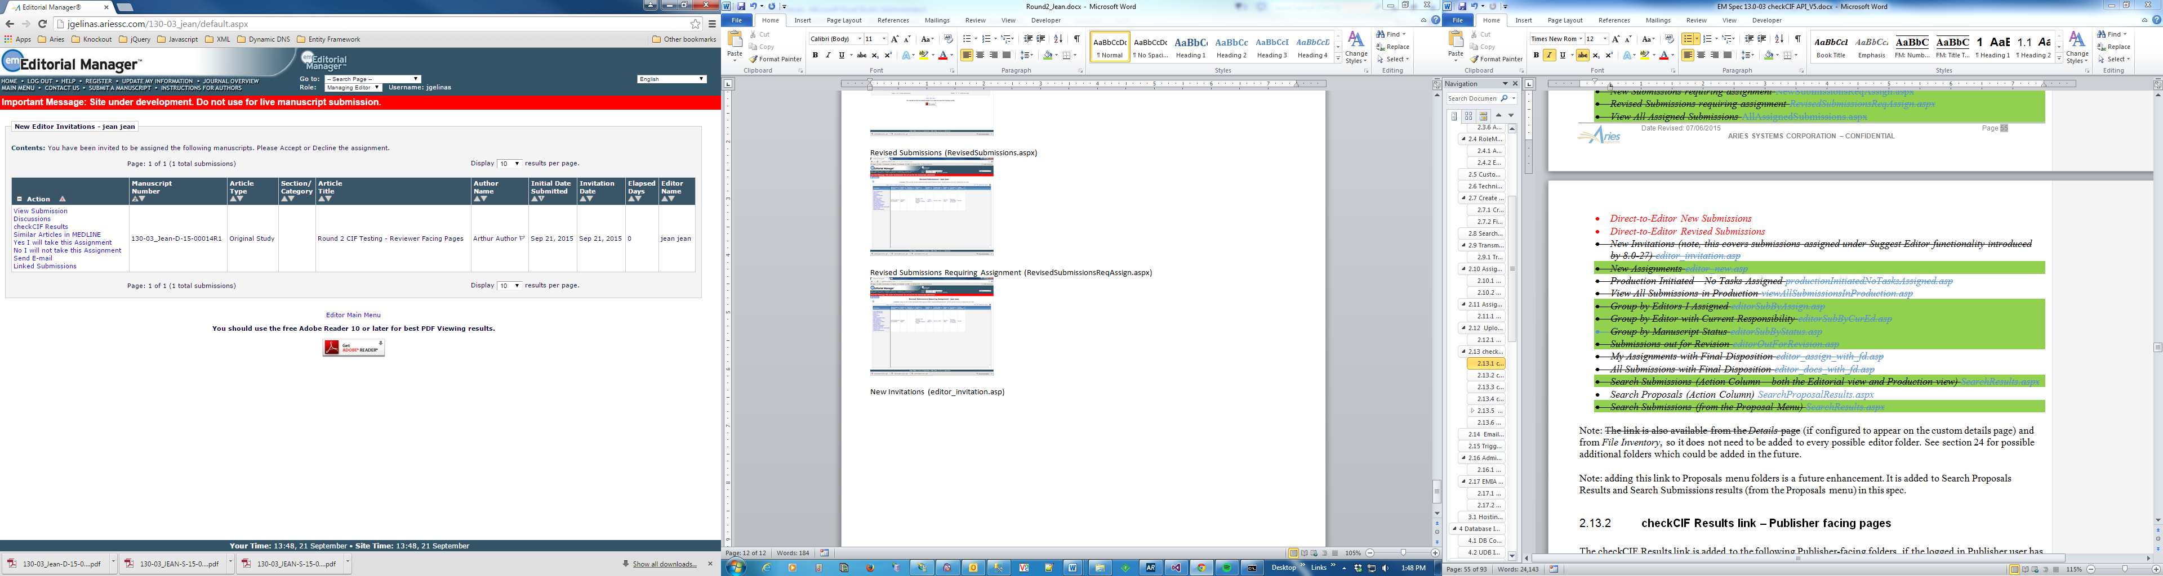

## ~~All Submissions with Final Disposition (editor _docs_with_fd.asp)~~

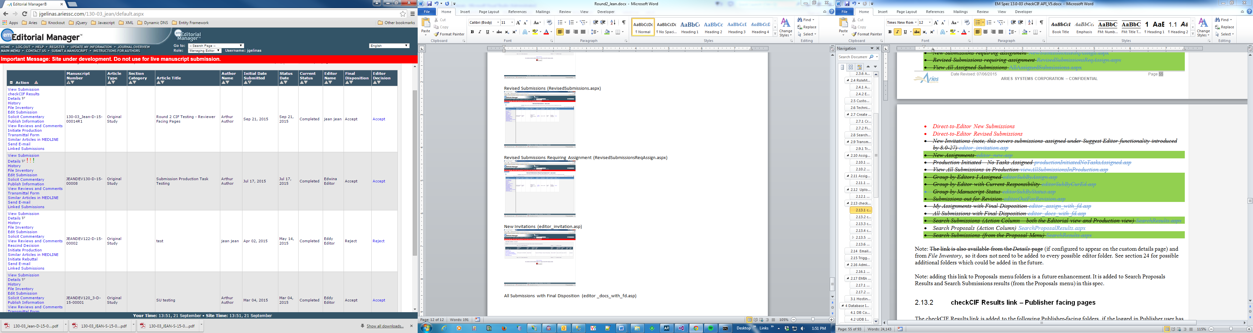

## ~~My Assignments With Final Disposition (editor_assign_with_fd.asp)~~

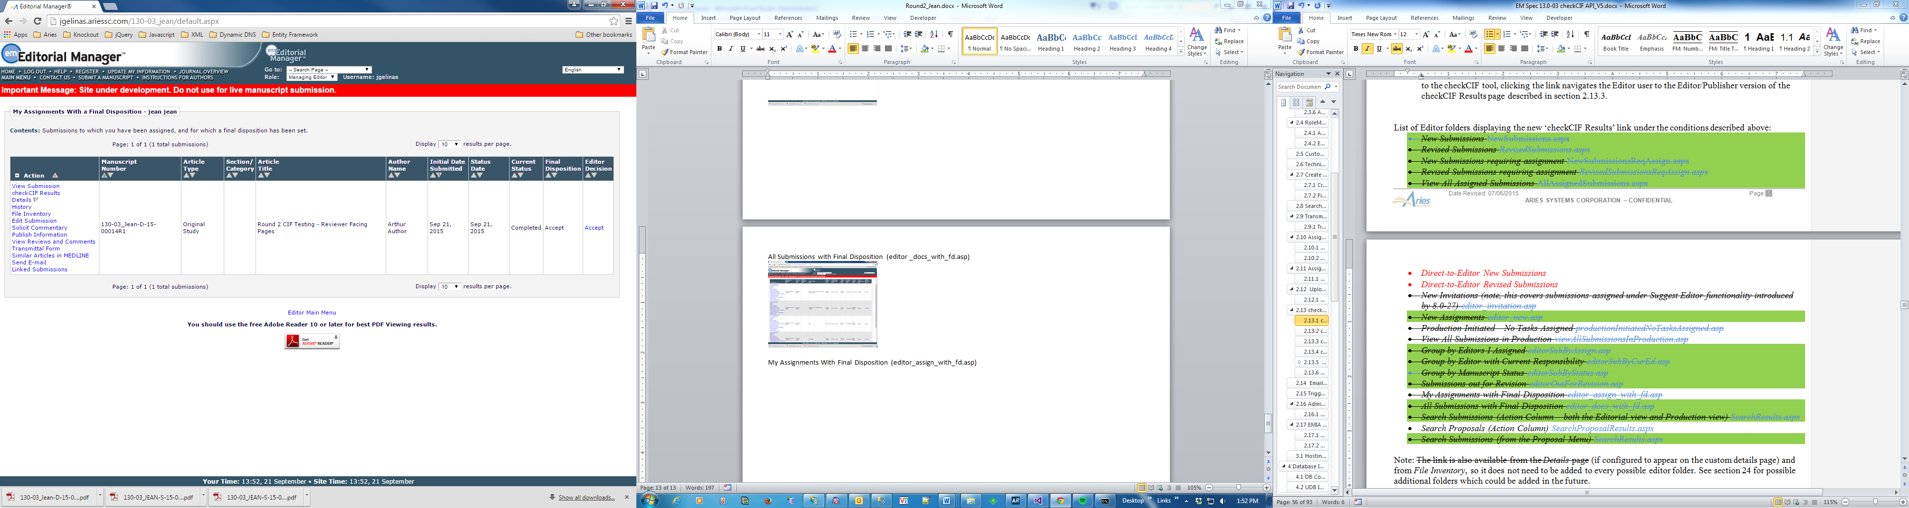

## ~~View All Submissions In Production (viewAllSubmissionsInProduction.asp)~~

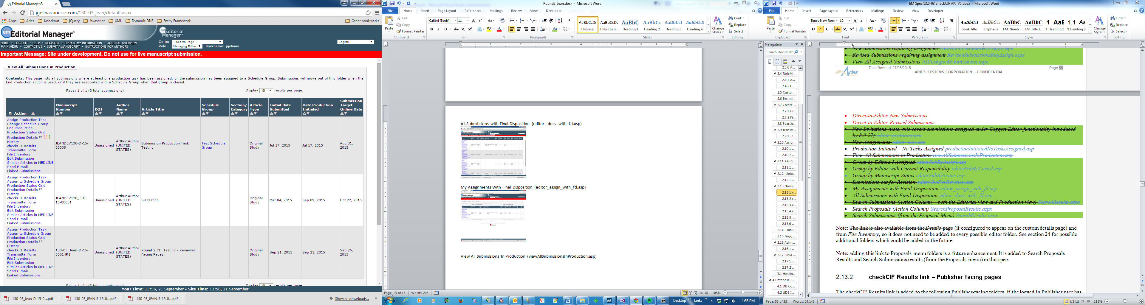

# PUBLISHER FACING PAGES

## ~~Accepted Submissions (publisherAcceptedManuscripts.asp)~~

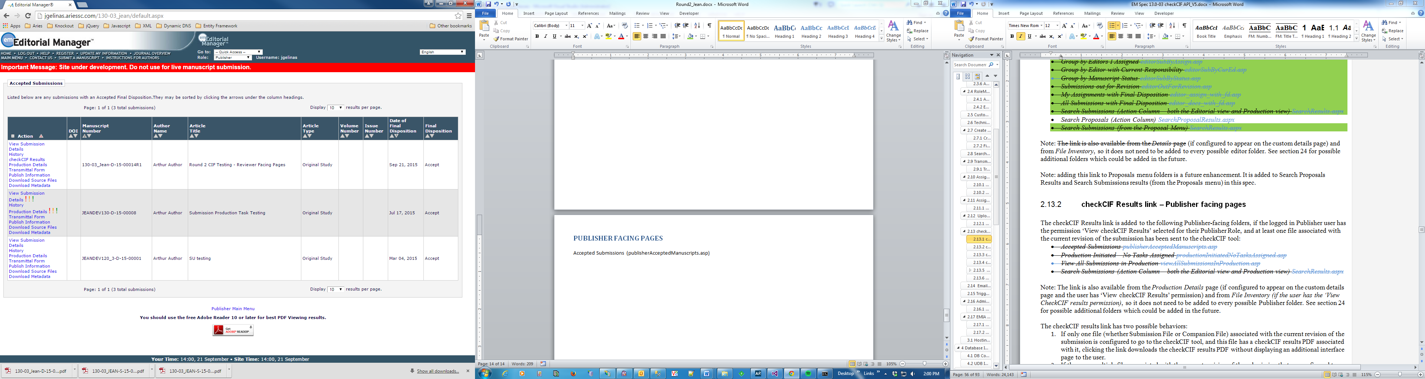

## ~~View All Submissions In Production (viewAllSubmissionsInProduction.asp)~~

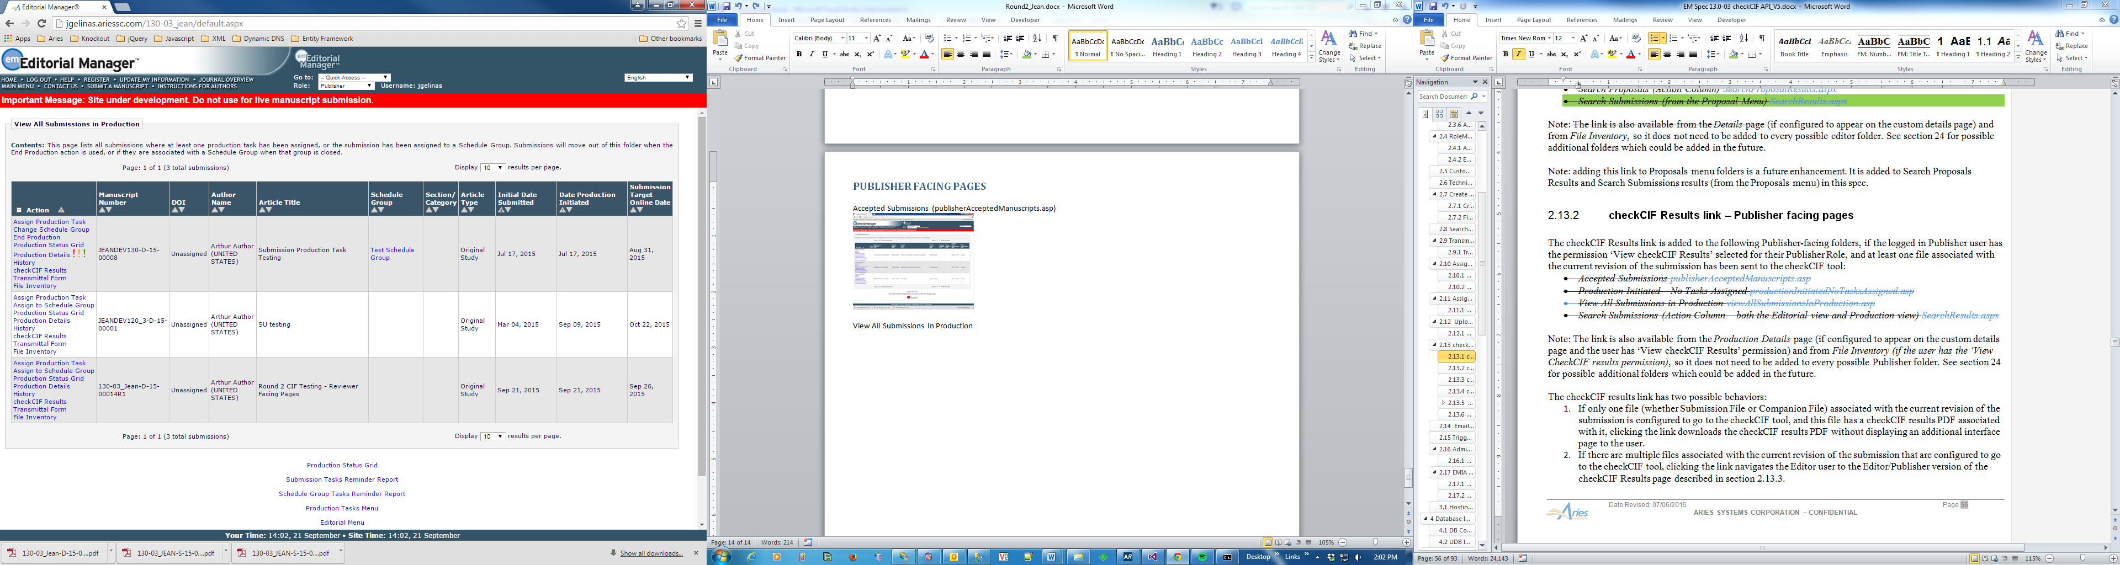

Submission Files

13/327, 14/319, 15/328, 16/329

Companion Files

17/312, 18/341

In Progress (1) – 15/328 (av1222.cif)

Error (2) – 13/327 (gg2036.cif)

Completed (3) – 17/312 (cv6285.cif)